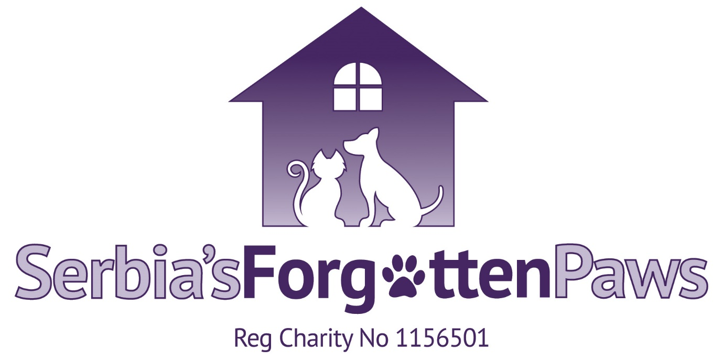

Pre Adoption Application:

Your name:
Your full address with post code:
Contact phone numbers:
Your email:

Which dog are you interested in?
Please list all the members of your household, including ages:
Is your home rented or own home?:
If rented, do you have written permission from your landlord to have dog?:
Your Garden
How high is your fence at the lowest point?

Is your garden fully secure?
Work
Do you work? If so, how many hours (including travel) would you be away from home?:
How often would the dog be left alone? And for how long?

Pets
Please list all the dogs in your household, including gender, ages and if neutered.:
Please list all other pets in your household, including species:
Please tell us about your previous dog experience:
Please tell us about the routine you would have with the dog:
Do you have any commitments in the next few months? (Examples: Moving house, changing routine, holidays, hospital stays):
Are you prepared to travel to meet/collect the dog if your home check is successful, how far are you able to drive?
All potential homes have a home check carried out before hand, are you happy with this?
I understand that a donation/adoption fee applies?

Please complete and email back to kelly@forgotten-paws.com

